Energy Review Sheet

Define each of the following (include equations, units, and definitions of each – if possible)

Types of Energy

Thermal Energy

Work

Conservation of Energy

Kinetic Energy

Gravitational Potential Energy

Energy Transformation

Efficiency

Power

Watt

Joule

1. Explain the difference between Mechanical Energy and Conservation of Energy. How are the two related in the problems we solve in physics class?
2. What is kinetic energy? How is it related to work?
3. What is gravitational potential energy? How is it related to work? What is meant by the idea of “reference line” and what does that mean for gravitational potential energy?
4. Jill fires a bullet of mass 15.2 g. It leaves the muzzle of a 61 cm rifle with a horizontal velocity of 922 m/s. Determine …
   1. the acceleration of the bullet in the rifle
   2. the net force the bullet feels
   3. the work done on the bullet while it is in the barrel
5. Leon is pulling a wagon with a force of 200 N at an angle of 24° above the horizontal. Find how much work he does in pulling the wagon a distance of 30 m. (Hint: W = FΔd ∙ cos24°)
6. Ada drives a 2100 kg car starts from rest and accelerates at a rate of 2.6 m/s2 for 4 s. Find
   1. The displacement of the car
   2. The net force acting on the car
   3. The net work done on the car
   4. The power of the car
   5. The car’s velocity after 4 seconds
   6. The change in the car’s kinetic energy
7. Billy is mowing his lawn by pushing his 11kg lawnmower against a frictional force of 86 N over a distance of 22 m
   1. What force should Billy apply to keep the lawn mower moving at a constant velocity?
   2. The work) done by Billy to keep the lawnmower moving
   3. The work done by friction
   4. If he uses 2180 J of energy what is Billy’s efficiency?
8. Chris is piloting an 1800 kg fighter jet 290 m in the air. The plane enters a dive with an initial speed of 15 m/s and accelerates dropping a distance of 30 m.
   1. Using the ground as a reference point find the total energy at the beginning of the dive
   2. What will the kinetic energy of the plane be at the end of the dive
   3. Find the speed of the plane at the end of the dive
9. Wesker throws a rock straight upwards with a velocity of 20 m/s off a bridge that is 125 m high relative to the water. Find
   1. The greatest height that the rock reaches (relative to the water)
   2. The speed of the rock as it passes Wesker on the way to the water
   3. The speed of the rock just as it strikes the water
10. Fill in the following chart. Assume the train has a speed of 3 m/s at the top (neglect friction)

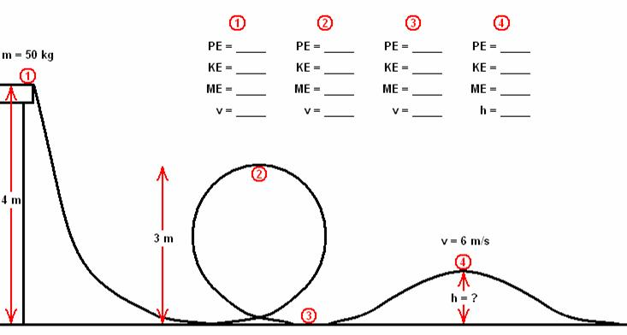

Answers

1. a.2.59 x 105 m/s2 b. 1.06 x 104 N c. 6461 J
2. 5481 J
3. a.20.8 m b. 5460 N c. 1.14 x 105 J d. 10.4 m/s e. 1.14 x 105 J
4. a. 86 N b. 1892 J c. -1892 J d. 86.8%
5. a. 3.54 x 106 J b. 4.88 x 105 J c. 28.5 m/s
6. a. 145 m b. 20 m/s c. 53.4 m/s
7. the h value at point 4 will be 2.6 m

|  |  |  |  |  |
| --- | --- | --- | --- | --- |
|  | 1 | 2 | 3 | 4 |
| Eg (PE) | 1960 | 1470 | 0 | 1285 |
| Ek (KE) | 225 | 715 | 2185 | 900 |
| Em (ME) | 2185 | 2185 | 2185 | 2185 |
| V | 3 | 5.3 | 9.3 | 6 |